**Exploratory Data Analysis on Airbnb Bookings**

**Bhoomika**

**Team Denver**

**Data Science Student**

**Alma Better**

**CONTENTS**

* **About the Airbnb**
* **Problem statement**
* **Data Exploration**
* **Data Cleaning**
* **Host and neighbourhood group**
* **Location of neighbourhood group**
* **Price distribution across neighbourhood**
* **Popular neighbourhood by review**
* **Preferred room types**
* **Limitation**
* **Scope of Improvement**
* **Conclusion**

**Introduction:**

Airbnb, Inc., based in San Francisco, California, operates an online marketplace focused on short-term homestays and experiences. The company acts as a broker and charges a commission from each booking. The company was founded in 2008 by Brian Chesky, Nathan Blecharczyk, and Joe Gebbia. Airbnb is a shortened version of its original name, AirBedandBreakfast.com. The company has been the subject of criticism for lack of regulations and enabling increases in home rents.

**Problem Statement:**

Data analysis on millions of listings provided by Airbnb is a main factor for the company. These millions of listings have a lot of data - data that can be analyzed and used for security, business decisions, understanding of customers' and providers' (hosts) behaviours and performance on the platform, guiding marketing initiatives, implementation of innovative additional services etc.

* With help of python data visualisation, libraries. We will try to solve the answer of the following questions
* What can we learn about the different hosts and areas?
* What can we learn from prediction’s ( prices , reviews etc. )
* Which type of rooms are customer demands in most popular neighborhood, neighbourhood_group
* Why type of reviews is made by the most of costumer’s
* Limitation in Airbnb’s data
* Scope of Improvement (How we help to resolve the problem)

**Dataset Analysis ( variable name ):**

The dataset contains 48895 observations with 16 features. This data file includes all needed information to find out more about hosts, geographical availability, necessary metrics to make predictions and draw conclusions. Let us look through our features,

* **Id :-**It is a particular identity number of property which is given to customer(host)
* **Name :-** It gives the name of property given to customer
* **Host_id :-** It is the identity number of host who have register on airbnb
* **Host_name :-**It is the customer name who registered their property on Airbnb
* **Neighbourhood_group :-** It tell the neighbourhood group present in the particular city ( ex :- NYK , San Francisco etc. )
* **Neighbourhood :-** It tells the neighbourhood present in neighbourhood_group in the city.
* **Latitude :-** it gives the coordinate of listing
* **Longitude :-** it gives the coordinate of listing
* **Room_type :-** it tells the type to categorise the rooms
* **Price :-** it gives the price of rooms according to room_type
* **Minimum_nights :-** It gives the info about minimum nights required to stay in a single visit
* **Number_of_reviews :-** total count of reviews given by visitors.
* **Last_review :-** date of last review given.
* **Reviews_per_month :-** it gives rate of reviews given per month
* **Calculated_host_listings_count :-**it gives total no of listing registered under the host
* **Availability_365 :-** it gives the number of days for which a host is available in a year

latitude and longitude have represented a co-ordinate, neighbourhood_group, neighbourhood and room_type are columns of categorical type. last_review is a column of date type; we will convert it as required.

The distribution of numerical columns are as follows,

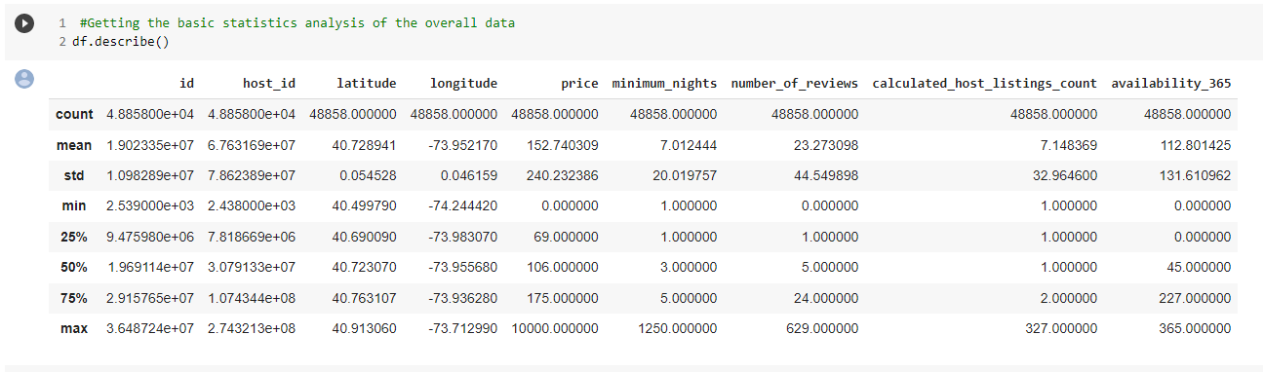

Fig 1. Statistical Distribution of Numerical Features

Other 3 important columns are,

* **neighbourhood_group:** It contains 5 unique hoods which are Manhattan, Brooklyn, Queens, Bronx & Staten Island.
* **neighbourhood:** It contains 211 unique neighbourhoods.

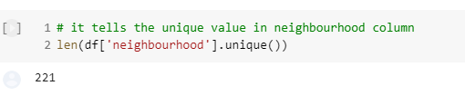

* **room_type:** It contains 3 unique room types which are Entire home/apt, Private room, Shared room

**Data Cleaning :**

**Fixing the null values**

We have drop the unnecessary null values like numbers_of_reviews, last review ,longitude, latitude and reviews_per_month ( because it has not much meaning full values )

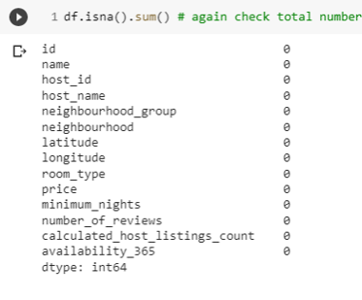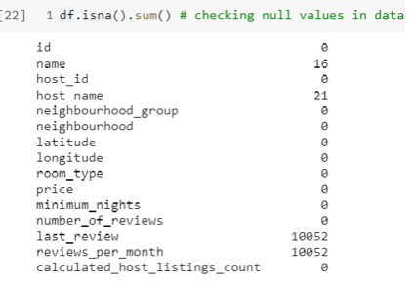

* The highest missing value is in reviews_per_month and last_reviews column, I thing this because most of people don't write the reviews . host_name and name also have the missing value this may be because of some technical issue.
* We can handle the missing value in review_per_month by default value.
* We can handle the missing value in name and host_name only by droping them.

**No of list made by host across Neighborhood Group**

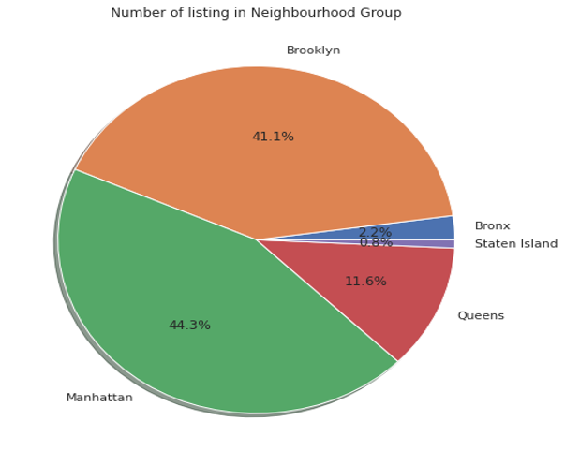

* It is observed that Manhattan has highest number of listing of 21661 which is 44.3% of total listing.
* Brooklyn has second highest number of listing 20104 which is 41.1% of total listing.
* Queens are at third place with 5666 listing and Bronx and Staten have least number of listing
* 85% of Airbnb are distributed in Manhattan and Brooklyn where as other very less Airbnb locations.
* Most of the people stay in Manhattan and Brooklyn.

**No of list made by host across Neighbourhood**

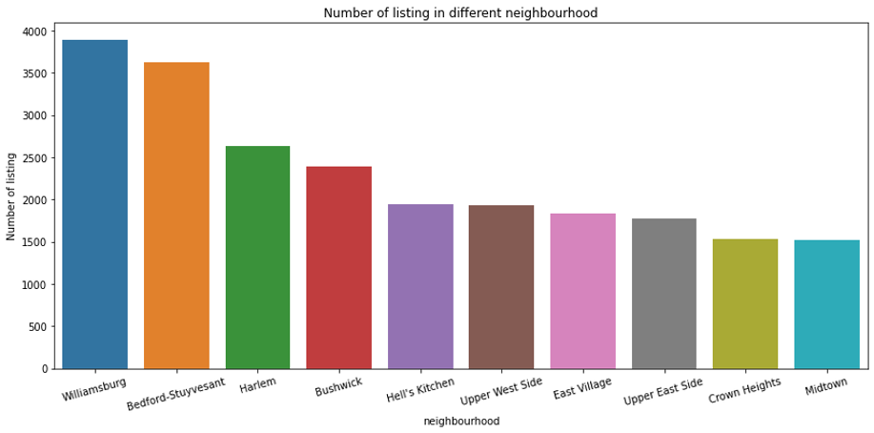

* Most of the Airbnb location are available in this top 15 neighbourhood and people prefer to stay here.
* The top 2 neighbourhood which is most prefer by people is Williamsburg and Bedford-Stuyvesant
* Most of peoples wants to live in Williamsburg and Bedford-Stuyvesant

**Location of Neighbourhood Groups**

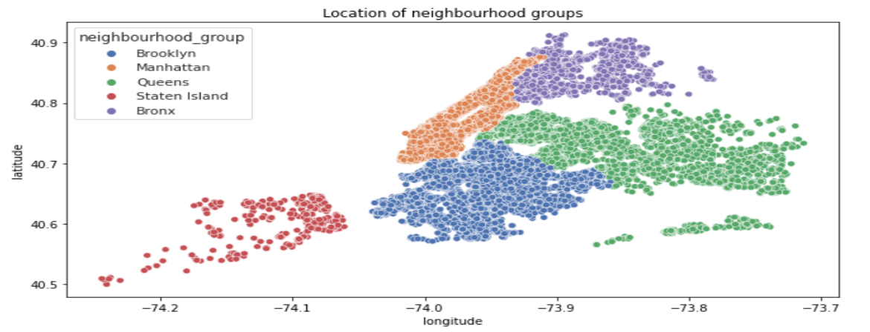

**There are 221 unique neighbourhoods falls under 5 groups**

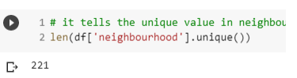**Price distribution across neighbourhood_group**

**( which room type are most expensive and where it is located )**

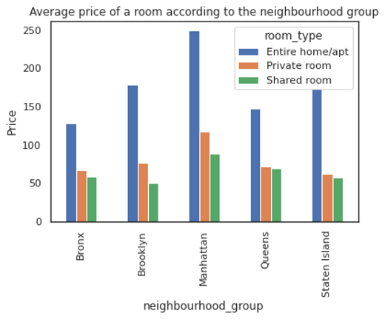

* Manhattan has the highest price for room types with Entire home/apt ranging to nearly 222$/night, followed by Private room with 109$/night . And it’s obvious being the most expensive place to live in!
* In Manhattan you opt for entire home 40% more amount then opt entire home in Brooklyn.
* location wise distribution of price shows that Manhattan has expensive and Bronx has low priced rooms.
* If you opt for Bronx you have to pay 50% less then Manhattan

. **Price distribution across neighborhood**

**( which room type are most expensive and where it is located )**

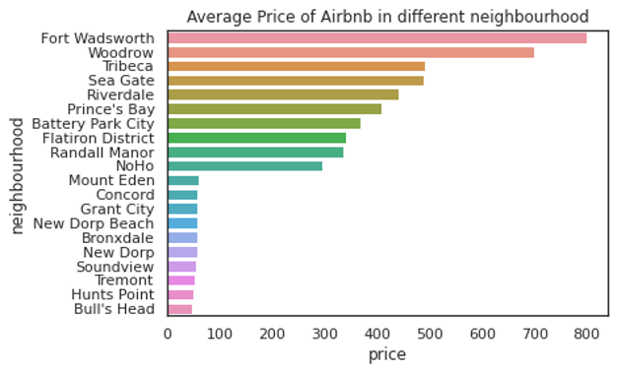

* Most expensive neighbourhood is fort Wadsworth followed by Woodrow then Tribeca.
* Most cheapest neighbourhood is hunts point followed by bull's head then Soundview.

**Popular neighborhood by review**

**( which room type are most and where it is located )**

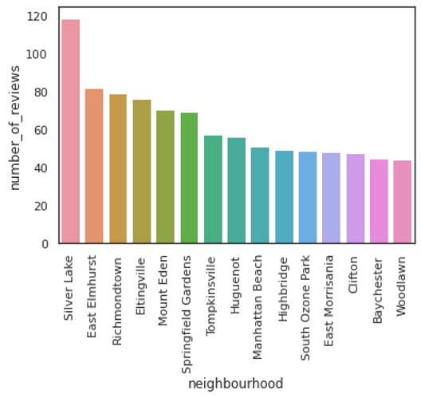

* The most review neighbourhood is silver lake with average reviews of 118 per month, followed by East Elmhurst with average review of 83

**Preferred room types**

**( which room type people are preferred to stay longer )**

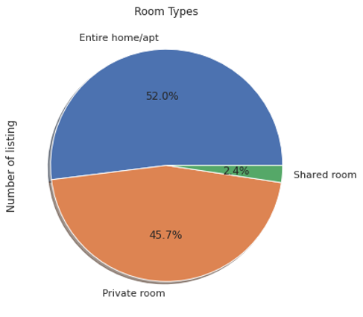

* The demand of entire home and private room is more high and people also choose entire home and private room.
* As per the dataset 97.7% of them are entire home or private room and only 2.4% of them are share room.

**Preferred room types**

**( Location )**

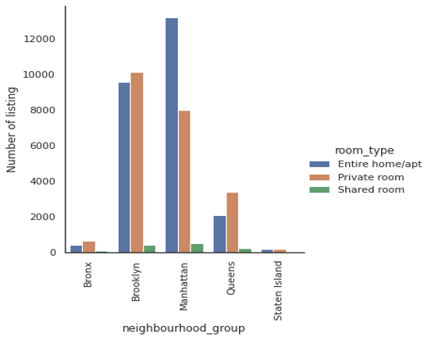

* The demand of entire home is more in Manhattan followed by Brooklyn and the price is also high.
* Demand of private room is more in Brooklyn followed by Manhattan.

**Correlation Matrix :-**

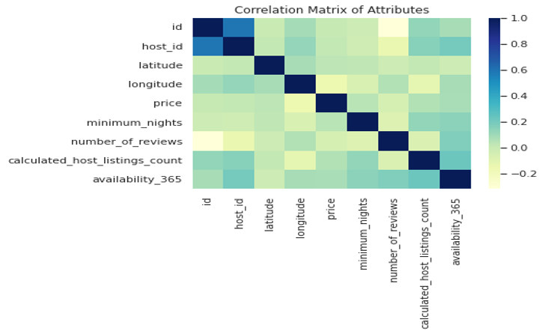

**All the features are less correlated with price, regression taking price as target, will be less accurate**

**Limitation:**

* Dataset features in terms of modern world, are of very poor quality in deciding the valuation of a property
* User ratings of hosts aren’t available, it would’ve been better to rank our hosts based on user satisfaction and ratings. Normally a low rated property tends to lower their price.
* In order to have a better analysis regarding the quality of the properties, it would be interesting if we had an analysis of sentiments with property valuations.
* The exact number of guests count also missing

**Scope of Improvement:**

* As dataset has less number of features to decide a property, more features can be added like bedroom, bathroom, property age (it might be one of the most important one), tax rate, distance to nearest airport, hospital, metro station or schools etc.
* In presence of ratings, hosts can be classified and ranked, gives a special discount or offer to highest rated hosts following marketing strategy
* Time series analysis can be done to make decision on the rate in the tourist season.

**Conclusion:**

From the entire analysis, it can be concluded that,

* Most visitors room is entire home/apt which is 52 percent after that private room which is 45.7 percent and least prefered room is shared room which is 2.4 percent.
* Manhattan has the highest price for room types with Entire home/apt ranging to nearly 249$/night, followed by Private room with 116$/night.
* Less preference places are staten island and Bronx.
* Though location of property has high relation on deciding its price, but a property in popular location doesn’t mean it will stay occupied in most of the time.
* Performing a regression on this dataset may result in high error rate, as the features given in this dataset, are of very poor quality in deciding the property valuation. We can see this by looking at correlation heatmap. We would need more features like bedrooms, bathroom, property age, room extra amenities, distance to nearest hospital, stores or schools. These features might have a high relation with price.

THE END